**Demo 4**

**Perform Conditional Formatting: Use Icon Set Rules**



**Steps to be followed:**

**Step 1: Open the Excel file**

* 1. Open the file named **Formatting.xlsx**

**Step 2: Apply conditional formatting on the Date column**

* 1. Choose the column **Net Sales.** On the basis of the sales amount, apply the Icons Set rules:
* If the sales amount is greater than 8000, show a green arrow in an upward direction
* If the sales amount is between 5000 and 8000, show a yellow arrow in horizontal direction
* If the sales amount is less than 5000, show a red arrow in a downward direction

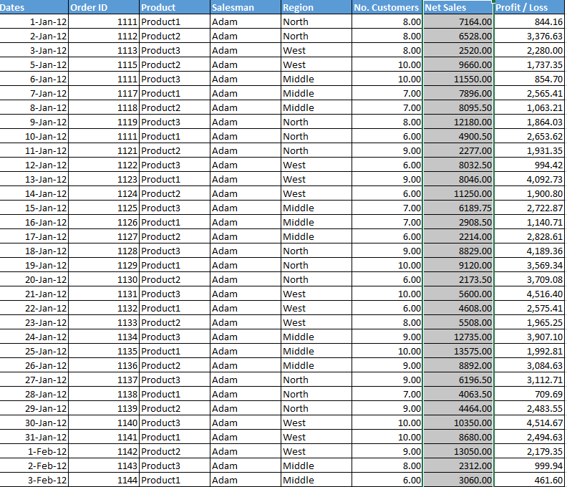

* 1. In the Home tab, under Styles panel, choose Conditional formatting. Click on the 3 arrows under Icon Set Rules:

* 1. The data looks like the following:

* 1. Apply the rules on the net sales amount now. Click on **Manage Rules** under the conditional formatting icon under the Styles panel of the Home tab

* 1. Click on Edit Rule and click on OK

* 1. Update the rules as shown below and click on OK. Click on OK again in the parent dialog box

* 1. The results look like the following. The icon sets are shown as below:

